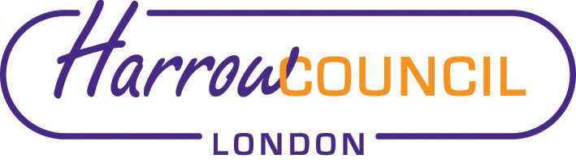

Harrow SACRE Meeting

Tuesday 29 September 2020 at 7.30 p.m.
To be held via video conferencing

Enquiries & apologies to:
Vivian Wright, Clerk to SACRE
vmwright@waitrose.com

Adviser to SACRE: Lesley Prior

Agenda
- Welcome:

- Election of Chair and Vice-Chair

- Apologies for absence:

- Minutes of the last meeting on 25 June 2020: to agree the minutes as a true record.

- Matters arising from the minutes

- Local and National Updates

- Days of religious observance: agree 2020-21 edition

- Determinations

- Vaughan Determination

- Priorities for the year ahead

- Annual report

- News from Faith Groups relating to schools

- Any Other Business
- SACRE address list - update

- Future Dates

- Thursday 10 December
- Tuesday 9 March 2021

